QuickStart 2026: Capacity-Building for Community–Academic Research Partnerships
Applications Now Open

Release Date: September 22, 2025

Submission Date:
- Individual community members or academics who need help finding a partner: January 21, 2026, 5:00 PM PST
- Community-Academic teams (new or existing): March 12, 2026, 5:00 PM PST.

 | 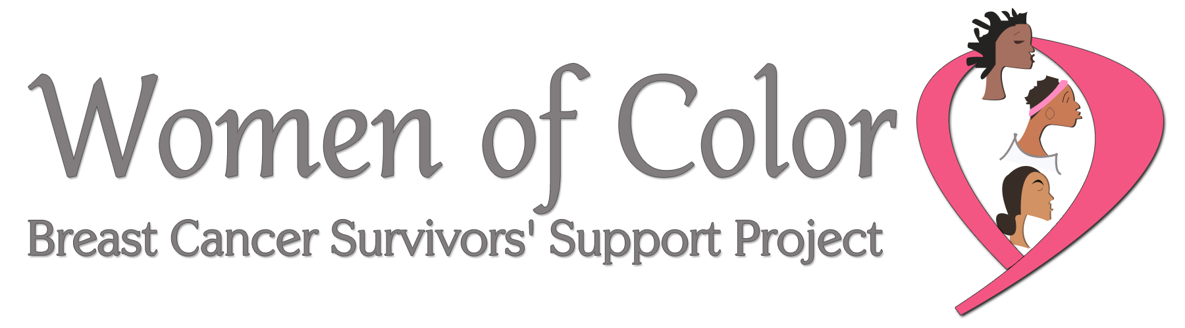 | 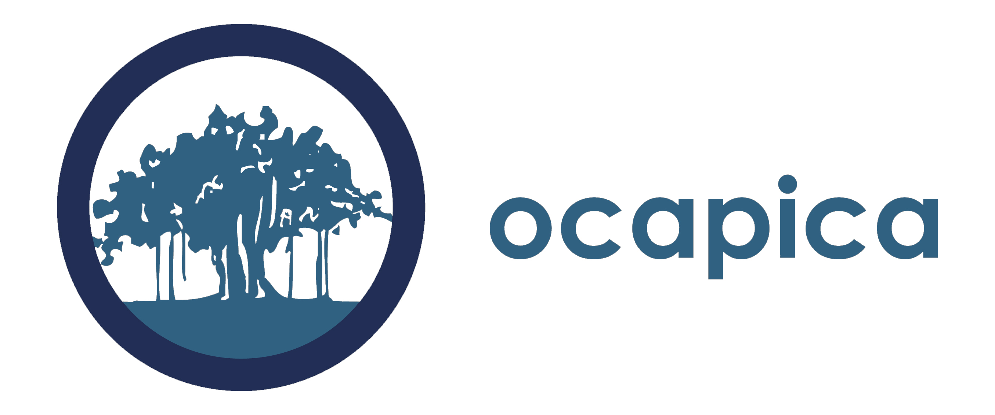

What is QuickStart?
An intensive training program for community–academic teams to develop competitive, community-partnered participatory research (CPPR) proposals on breast cancer.

Who Should Apply?
- Teams of one community Co-PI and one academic Co-PI (new or existing partnerships).
- Individual community members or academics seeking a partner (must apply by early deadline).
- California-based applicants prioritized; out-of-state welcome (cover own travel).

Benefits
- Build and strengthen community–academic partnerships
- Learn CPPR methods and best practices
- Develop draft CBCRP grant proposals
- Receive tailored technical assistance, mentorship, and peer feedback
- Gain skills, data, and credibility for future funding and policy change

Program Format
- Two in-person sessions (April & June 2026, CA locations)
- Online assignments and webinars (April–Dec 2026)
- Four technical assistance calls
- Mock grant review (Jan 2027)
Time Commitment: ~60–70 hours (April 2026 – Jan 2027)
Cost: Free. Travel/hotel support for California participants.

Key Dates
- Individuals seeking partners: Jan 21, 2026, 5 PM PST
- Teams: Mar 12, 2026, 5 PM PST
- Program runs April 2026 – Jan 2027

Sponsors
- California Breast Cancer Research Program (CBCRP)
- Orange County Asian and Pacific Islander Community Alliance (OCAPICA)
- Women of Color Breast Cancer Survivors’ Support Project (WOC)

Contact
QuickStartTP@gmail.com | Senaida.Poole@ucop.edu
Learn more: cbcrp.org/quickstart
QuickStart Application Guidelines for
Community Co-PIs seeking a Academic Co-PI

Submission date for individual community members or academics who need help finding a partner: Monday, January 21, 2026, 5:00 PM PST.

The Community co-PI should fill out the overview form on the next page and provide a narrative overview in response to the questions on the following pages. Please combine all pages of the application into a single word document and email it to QuickStart@cabreastcancer.org by 5pm PST on the deadline.

If the community co-PI is selected for the QuickStart program, the team will assist them in identifying and reaching out to potential academic co-PIs to work with. Additionally, we will make introductions to people if we know of potential candidates. The QuickStart team cannot promise that the community co-PI will be able to find a partner in advance of starting the program, however all reasonable efforts will be made to facilitate a match.

Your complete application (excluding letters of reference and resumes) should not exceed six pages. A downloadable word version of this is also available on the QuickStart webpage: http://cbcrp.org/funding-opportunities/crc/quick-start-training.html

Please submit your application as a word document.

Application Checklist:
Please include the following in your completed application:

- Overview of Community Partner Seeking a Academic Co-PI: See form on following page.
- Application questions: See questions on following pages.
- Letter of Reference. Includes a letter of reference from the organization you represent demonstrating support for your participation in QuickStart.
- Resume or Curriculum Vitae (CV) (Not to exceed 4 pages). Each person must submit either a resume (community partner) or a CV (academic partner) that is not to exceed four pages.

Overview of Community Partner Seeking a Academic Co-PI

Community Co-PI Name
Organization Name
Address
Email
Work Phone
Cell Phone
Executive Director Name
Work Phone
Email
Please describe the community you are a part of and/or represent.

What are the primary issues related to breast cancer that affect your community?

What disparities issues are of most concern to your community?

What environmental issues related to breast cancer are of most concern to your community?

Have you or your organization worked on a research project before? If so, please briefly describe.

Application Questions for a Community Co-PI Seeking an Academic Co-PI

Prepare a two-to-three-page overview in response to the questions below. Please include the questions with the answers filled in underneath when you submit.

- Describe the mission of your organization, the issues the organization focuses on, the geographic reach of the organization, the demographics of the population the organization serves, and the types of services the organization provides.
- Describe your role in your organization. What experience, interests and skills do you have that are relevant to conducting community-partnered participatory research?

- Describe your experience working in partnerships and/or collaborations generally and (if applicable) in community-partnered participatory research.
- Describe your organization’s experience collaborating with others beyond what you describe in #3.

- Describe your research interests. For example, describe the types of research questions that are interesting to you and the group/organization you are representing. Please be as detailed as possible. This is important if you would like assistance finding a academic partner. The more we know about your interests, the better we will be able to help you.

- If there are other individuals who are likely to be significantly involved in the research process from your community group or organization, please describe them and their proposed contribution. Please note: if you would like one of them to be considered for participation in the program, please indicate who they are and why it would be important for them to participate. QuickStart cannot guarantee that more than the community co-PI and academic co-PI will be able to participate in the program; however, we will consider a third partner if there is available space.

- Given the research needs and interests of the organization, why is the individual applying a good Community Co-PI candidate for this program?

- How will the organization select a replacement for you if you resign from your position?

- Is there anything else you would like the QuickStart team to know as we consider your application?
QuickStart Application Guidelines for
Academic Co-PIs seeking a Community Co-PI

Submission date for individual community members or academics who need help finding a partner: Monday, January 21, 2026, 5:00 PM PST.

The Academic co-PI should fill out the overview form on the next page and provide a narrative overview in response to the questions on the following pages. Please combine all pages of the application into a single word document and email it to QuickStart@cabreastcancer.org by 5pm PST on the deadline.

If the academic co-PI is selected for the QuickStart program, the team will assist them in identifying pathways to identifying and reaching out to potential community co-PIs to work with. Additionally, we will make introductions to community members if we know potential candidates. The QuickStart team cannot promise that the academic co-PI will be able to find a partner in advance of starting the program, however all reasonable efforts will be made to do this.

Your complete application (excluding letters of reference and resumes) should not exceed six pages. A downloadable word version of this is also available on the QuickStart webpage: http://cbcrp.org/funding-opportunities/crc/quick-start-training.html

Please submit your application as a word document.

Application Checklist:
Please include the following in your completed application:

- Overview of Academic Co-PI Seeking a Community Co-PI: See form on following page.
- Application questions: See questions on following pages.
- Letter of Reference. Includes a letter of reference from the organization you represent demonstrating support for your participation in QuickStart.
- Resume or Curriculum Vitae (CV) (Not to exceed 4 pages). Each person must submit either a resume (community partner) or a CV (academic partner) that is not to exceed four pages.

Overview of Academic Co-PI Seeking a Community Co-PI

Academic Co-PI Name
Institution
Address
Email
Work Phone
Cell Phone
Please give some key words of the type of scientific research you are qualified to do (ex. Toxicology, Epigenetics, etc)

Have you worked on either breast cancer in the past? Please describe briefly.

Have you worked on disparities-related research in the past? Please describe briefly.

Have you worked on environmental exposures-related research in the past? Please describe briefly.

Please indicate the number of years of experience in your field since completion of your doctoral degree.

Please list the year, funder, and name of study of most recent NIH RO1 funding.

In cases where the academic Co-PI does not have this experience, the QuickStart program will coordinate directly with the academic Co-PI to put an acceptable mentorship plan in place for the duration of QuickStart.

Application Questions for an Academic Co-PI Seeking a Community Co-PI

Prepare a two-to-three-page overview in response to the questions below. Please include the questions with the answers filled in underneath when you submit.

- Describe the mission of your institution, research priorities and focus, geographic reach (if relevant), the demographics of the population(s) served, etc.
- Describe your role in your institution. What experience, interest and research skills do you have that are relevant to conducting community-partnered participatory research?

- Describe your experience working in partnerships and/or collaborations generally and (if applicable) in community-partnered participatory research.

- Describe your institution’s experience collaborating with others beyond what you describe in #3.

- Why are you interested in being part of a CPPR team?

- Describe your research interests. For example, describe the types of research questions that are interesting to you. Please be as detailed as possible. This is important if you would like assistance finding a community partner. The more we know about your interests, the better we will be able to help you.

- If there are other individuals who are likely to be significantly involved in the research process from your institution, please describe them and their proposed contribution. Please note: if you would like one of them to be considered for participation in the program, please indicate who they are and why it would be important for them to participate. QuickStart cannot guarantee that more than one academic co-PI will be able to participate in the program; however, we will consider a third partner if there is available space.

- Given the research needs and interests of the institution, why is the individual applying a good Academic Co-PI candidate for this program?

- How will your team maintain quality scientific leadership of this project if you resign from your position at your institution or organization?

- Is there anything else you would like the QuickStart team to know as we consider your application?

QuickStart Application Guidelines for
New and Existing Community-Academic Partnerships

Submission Date for community-academic teams (new or existing): Thursday, March 12, 2026, 5:00 PM PST.

Together the Academic co-PI and Community co-PI should fill out the partnership overview on next page and provide complete answers to questions A-C on following pages. Please combine all pages of the application into a single word document and email it to QuickStart@cabreastcancer.org by 5:00 PM on the deadline.

Your complete application (excluding letters of reference and resumes/CVs) should not exceed six pages. A downloadable word version of this is also available on the QuickStart webpage: http://cbcrp.org/funding-opportunities/crc/quick-start-training.html

Please submit your application as a word document.

Application Checklist:
Please include the following in your completed application:

- Partnership overview: See form on following page.
- Application questions: See following pages.
- Letter of Reference. Each of the partners includes a letter of reference from an organization or individual familiar with his/her work. For academic partners, a letter from a previous collaborator is appropriate. For community partners, a letter from your community organization in support of this application is required.
- Resume or Curriculum Vitae (CV) (Not to exceed 4 pages). Each partner must submit either a resume (community partner) or a CV (academic partner) that is not to exceed four pages.

Mentorship plan request: For accepted academically-trained academic applicants with less than five years of experience as a researcher after completing their doctoral degree, or without NIH R01 funding, an acceptable plan to gain mentorship from a seasoned investigator is required prior to the start of QuickStart. Please note: The packet for completing and submitting a mentorship plan will be provided to the academic Co-PI after the acceptance of the team. A mentorship plan will not be required of the community Co-PI.

Partnership overview for Academic and Community Partners

Community Co-PI Name
Organization Name
Address
Email
Work Phone
Cell Phone
Executive Director Name
Work Phone
Email
Academic Co-PI Name
Institution
Address
Email
Work Phone
Cell Phone

How many years has your team worked together? Or, If this is a new partnership, how did you meet?
What previous research studies have you conducted together (if applicable)?
Who is your community of interest?
What disparities issues are of most concern to you?
What environmental issues in breast cancer are of most concern to you?
If you are not planning to investigate disparities and/or environmental issues in breast cancer what are your primary issues of concern?
Please indicate the number of years of experience in your field since completion of your doctoral degree.
Please list the year, funder, and name of study of most recent NIH RO1 funding.

In cases where the academic Co-PI does not have this experience, the QuickStart program will coordinate directly with the academic Co-PI to put an acceptable mentorship plan in place for the duration of QuickStart.
Application Questions
A. Overview of your partnership (2–3 pages).
Together the community co-PI and academic co-PI prepares a two-to-three-page overview in response to the questions below. Please include the questions with the answers filled in underneath when you submit.

  - Who is part of your partnership? What experience, interests, and skills do they bring?

  - Describe your experience and position in your organization/institution.

  - How did your partnership meet and why have you chosen to work together? If you are an existing partnership, how did you begin to work together and what is your history of working together?

  - Describe each partner’s experience working in partnerships and/or collaborations (other than above) and (if applicable) in community-partnered participatory research.

  - Describe your common research interests. For example, describe the types of research questions that are interesting to you.

  - If there are other individuals who are likely to be significantly involved in the research process with your partnership, please describe them and their proposed contribution. Please note: if you would like one of them to be considered for participation in the program, please indicate who they are and why it would be important for them to participate. QuickStart cannot guarantee that more than two partners will be able to participate in the program; however, we will consider a third partner if there is available space.

B. Description of the Organization/Institution Involved (1–2 pages each). Each partner prepares a one-to-two-page overview of their organization/institution they will represent in the QuickStart program, that includes the following details. Please include the questions with the answers filled in underneath when you submit.

- Describe the mission of the organization/institution, the issue the organization/institution focuses on, the geographic reach of the organization/institution, the demographics of the population the organization/institution serves, and the types of services the organization/institution provides.
- Describe your organization/institution’s experience collaborating with others.

- Describe the research interests of the organization/institution (if different than above).

- Given the research needs and interests of the organization/institution, why is the individual applying a good candidate for this program?

- How will the organization/institution select a replacement for the individual if he/she resigns his/her position with the organization/institution?

C. Is there anything else you would like the QuickStart team to know as we consider your application?

